POU Customer Excellence Assessment Submission

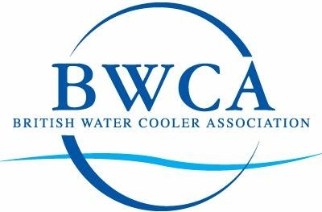
Name

Workshop date

Role

Business

Contact number

Email address

Line manager

Line manager contact number

Total word count
Min 1900 Max 2200
Date submitted online

1. Confirmation of own work

I confirm that the assessment, attached herewith, is all my own work and does not include any work completed by anyone other than myself.

2. Ethical approval

Throughout the programme you will be collecting data, analysing information; this may involve accessing company information, preparing questionnaires and structured interviews amongst other data collection methods. Ethical approval must be obtained prior to starting your research and data collection and this should be via your line/general manager.

I have considered and discussed the above with my line/general manager and accept that I am responsible for ensuring appropriate clearance and GDPR compliance where necessary.

Participants signature: ___________________________________________

Please complete each question based on the learning you gained and the actions you took to provide customer excellence. Each question should be used as a heading for your response to each
1 Introduction
Give the assessor a little bit of background about you and your role. Briefly highlight a sense of your key customers and what they expect from you. Remember that the assessor may not be familiar with your profession or specialist terms or language. 150 – 200 words

Assessor comments

2 Programme Learning
Here we need to understand your thoughts on what the main things are you feel you have leant or re-enforced as a result of the programme. What was your main learning from the programme? What did you like and why? What were you not so sure about and how did you follow up to try and understand a little more? 300 - 350 words

Assessor comments

3 Current Situation
Give a summary of your current key customers, what they expect from you and where you think you can build on delivering customer excellence. 300 - 350 words

Assessor comments

4 Improving Customer Service
Explain how you identified what needs to be improved, why and the key steps you need to take to improve customer service. What measures did you include to help assess your customer has received an improved service? 250 – 300 words

Assessor comments

5 Outcomes and Results
Give a description of what actually happened, what challenges or barriers did you face and what did you learn from making the customer excellence improvements? As a result of the changes, what were the specific new benefits for the customer? 300 – 350 words

Assessor comments

6 Customer and Manager Feedback
Proactively seek customer feedback following your recent contacts with your customers in which you increased your customer excellence support. Reflect on and sum up your thoughts on that feedback. What have you learned from your customer feedback and how can you build on this? You should then discuss this with your line manager to help reflect on the learning and agree customer service improvements as a result of the project. 300 - 350 words

Assessor comments

7 Conclusion
Give us your thoughts and reflections having now worked through the POU Customer Excellence programme and the post workshop assignment. What has worked for you, key behaviour changes, what are your thoughts in further self development in this area and how can you continue to add value? 300 - 400 words

Assessor comments

Once completed, upload a copy of this assignment to the online BWCA Moodle site. Once uploaded, this will trigger an email to Skills Channel TV and BWCA informing them that your assignment is ready for assessment. Please allow up to four weeks for your feedback.

Assessor summary

Result
Pass |  | Referred

